**Prerequisites**

Before you begin, ensure the following:

* **Amazon Redshift cluster is running** and its status is **available**.
* **Security Group Rules**: Ensure the security group associated with your Redshift cluster allows inbound access on port 5439 (default port for Redshift).

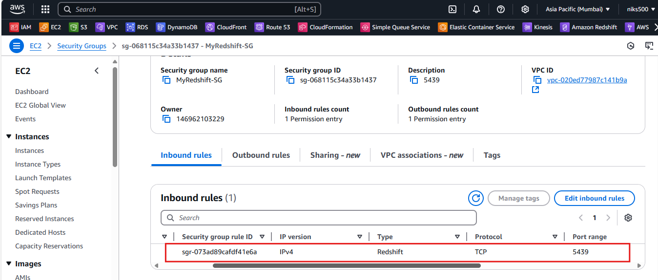

* **JDBC URL and Credentials**: You’ll need the following details to connect:
  + **Cluster endpoint** (hostname of the Redshift cluster).
  + **Port** (default is 5439).
  + **Database name**.
  + **Master username**.
  + **Master password**.

===========================================================================

**Steps to Connect Amazon Redshift to DBeaver**

**1. Download and Install DBeaver**

If you don't already have DBeaver installed, you can download it from the DBeaver website.

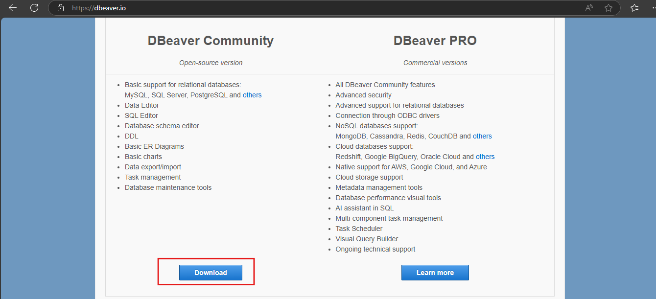

**2. Open DBeaver**

* Launch DBeaver after installing it.

**3. Create a New Database Connection**

1. In DBeaver, click on the **Database** menu at the top and select **New Database Connection**.

Alternatively, you can click the **"New Connection"** button from the toolbar or use the **Ctrl + N** keyboard shortcut.

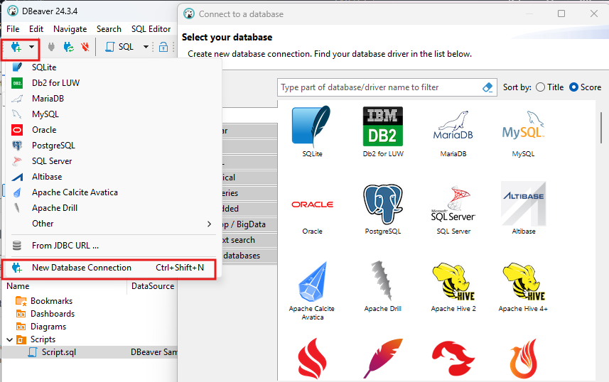

**4. Select Amazon Redshift as the Database Type**

1. In the **Connect to Database** window, type **Redshift** into the search bar or select **Amazon Redshift** from the list of database types.
2. Click **Next** to proceed.

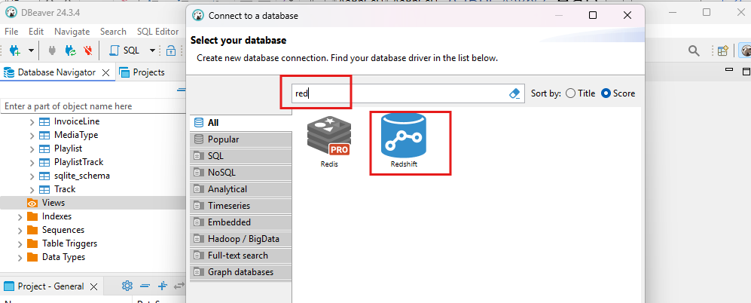

**5. Configure the Connection Settings**

1. **Connection Settings**: You will need to fill in the following details:
   * **Host**: Enter the **Cluster endpoint** of your Amazon Redshift cluster. This can be found in the AWS Console by going to **Amazon Redshift** → **Clusters** → **Your Cluster** → **Properties** → **Endpoint**.
     + Example: my-cluster-name.xxxxxx.us-west-2.redshift.amazonaws.com

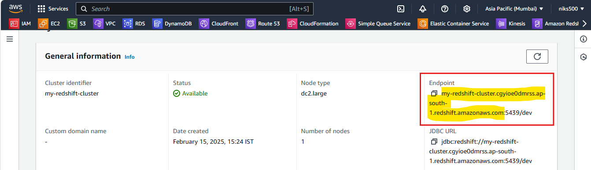

* + **Port**: Use the default Redshift port, which is 5439.
  + **Database**: Enter the name of the database you want to connect to. The default database is usually dev.
  + **Username**: Enter the **Master Username** you specified when creating the Redshift cluster (e.g., admin).
  + **Password**: Enter the **Master Password** for the specified user.

1. **Driver Settings**: DBeaver should automatically detect the appropriate JDBC driver for Redshift. If not, you can download the driver directly from within DBeaver.
   * Click on the **Driver** tab and click on **Download** to download the necessary driver files.

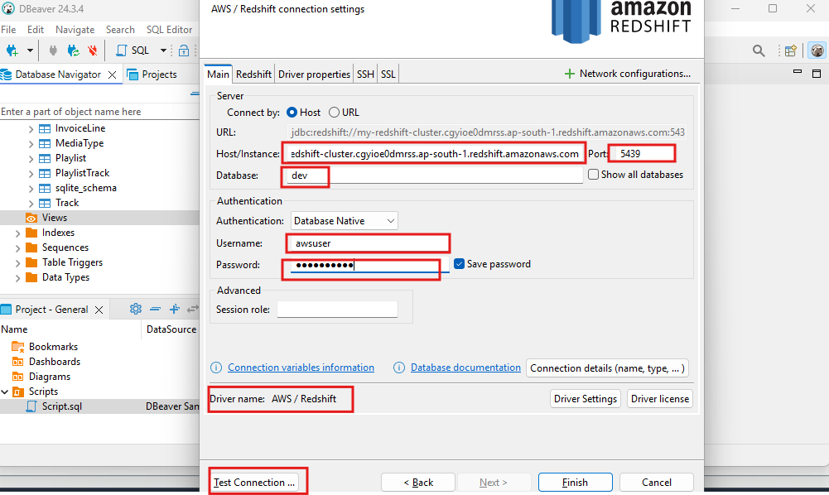

**6. Test the Connection**

* After entering the connection details, click on **Test Connection** to ensure that DBeaver can successfully connect to your Redshift cluster.

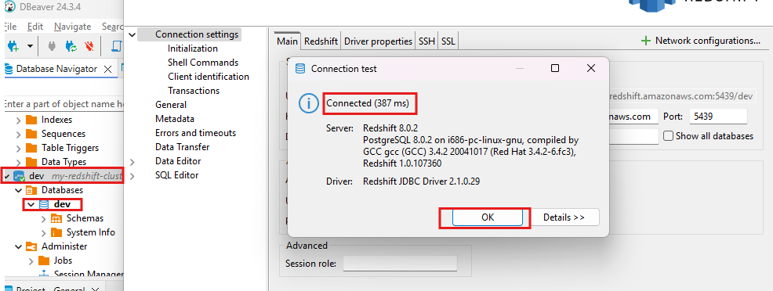

* + If everything is set up correctly, DBeaver will display a success message.
  + If there are issues, check your **Security Group** settings in the AWS Console to ensure the cluster is accessible.

**7. Save the Connection**

* Once the connection test is successful, click **Finish** to save the connection settings.

**8. Start Using Redshift in DBeaver**

* After saving the connection, your Redshift cluster will appear in the **Database Navigator** panel on the left side of the DBeaver interface.
* You can now **browse your Redshift databases**, **write SQL queries**, and **view tables** directly in DBeaver.

